**Project Design Phase-II**

**Data Flow Diagram & User Stories**

|  |  |
| --- | --- |
| Date | 14-10-2022 |
| Team ID | PNT2022TMID30061 |
| Project Name | Nutrition Assistant Application |
| Maximum Marks | 4 Marks |

**Data Flow Diagrams:**

A Data Flow Diagram (DFD) is a traditional visual representation of the information flows within a system. A neat and clear DFD can depict the right amount of the system requirement graphically. It shows how data enters and leaves the system, what changes the information, and where data is stored.

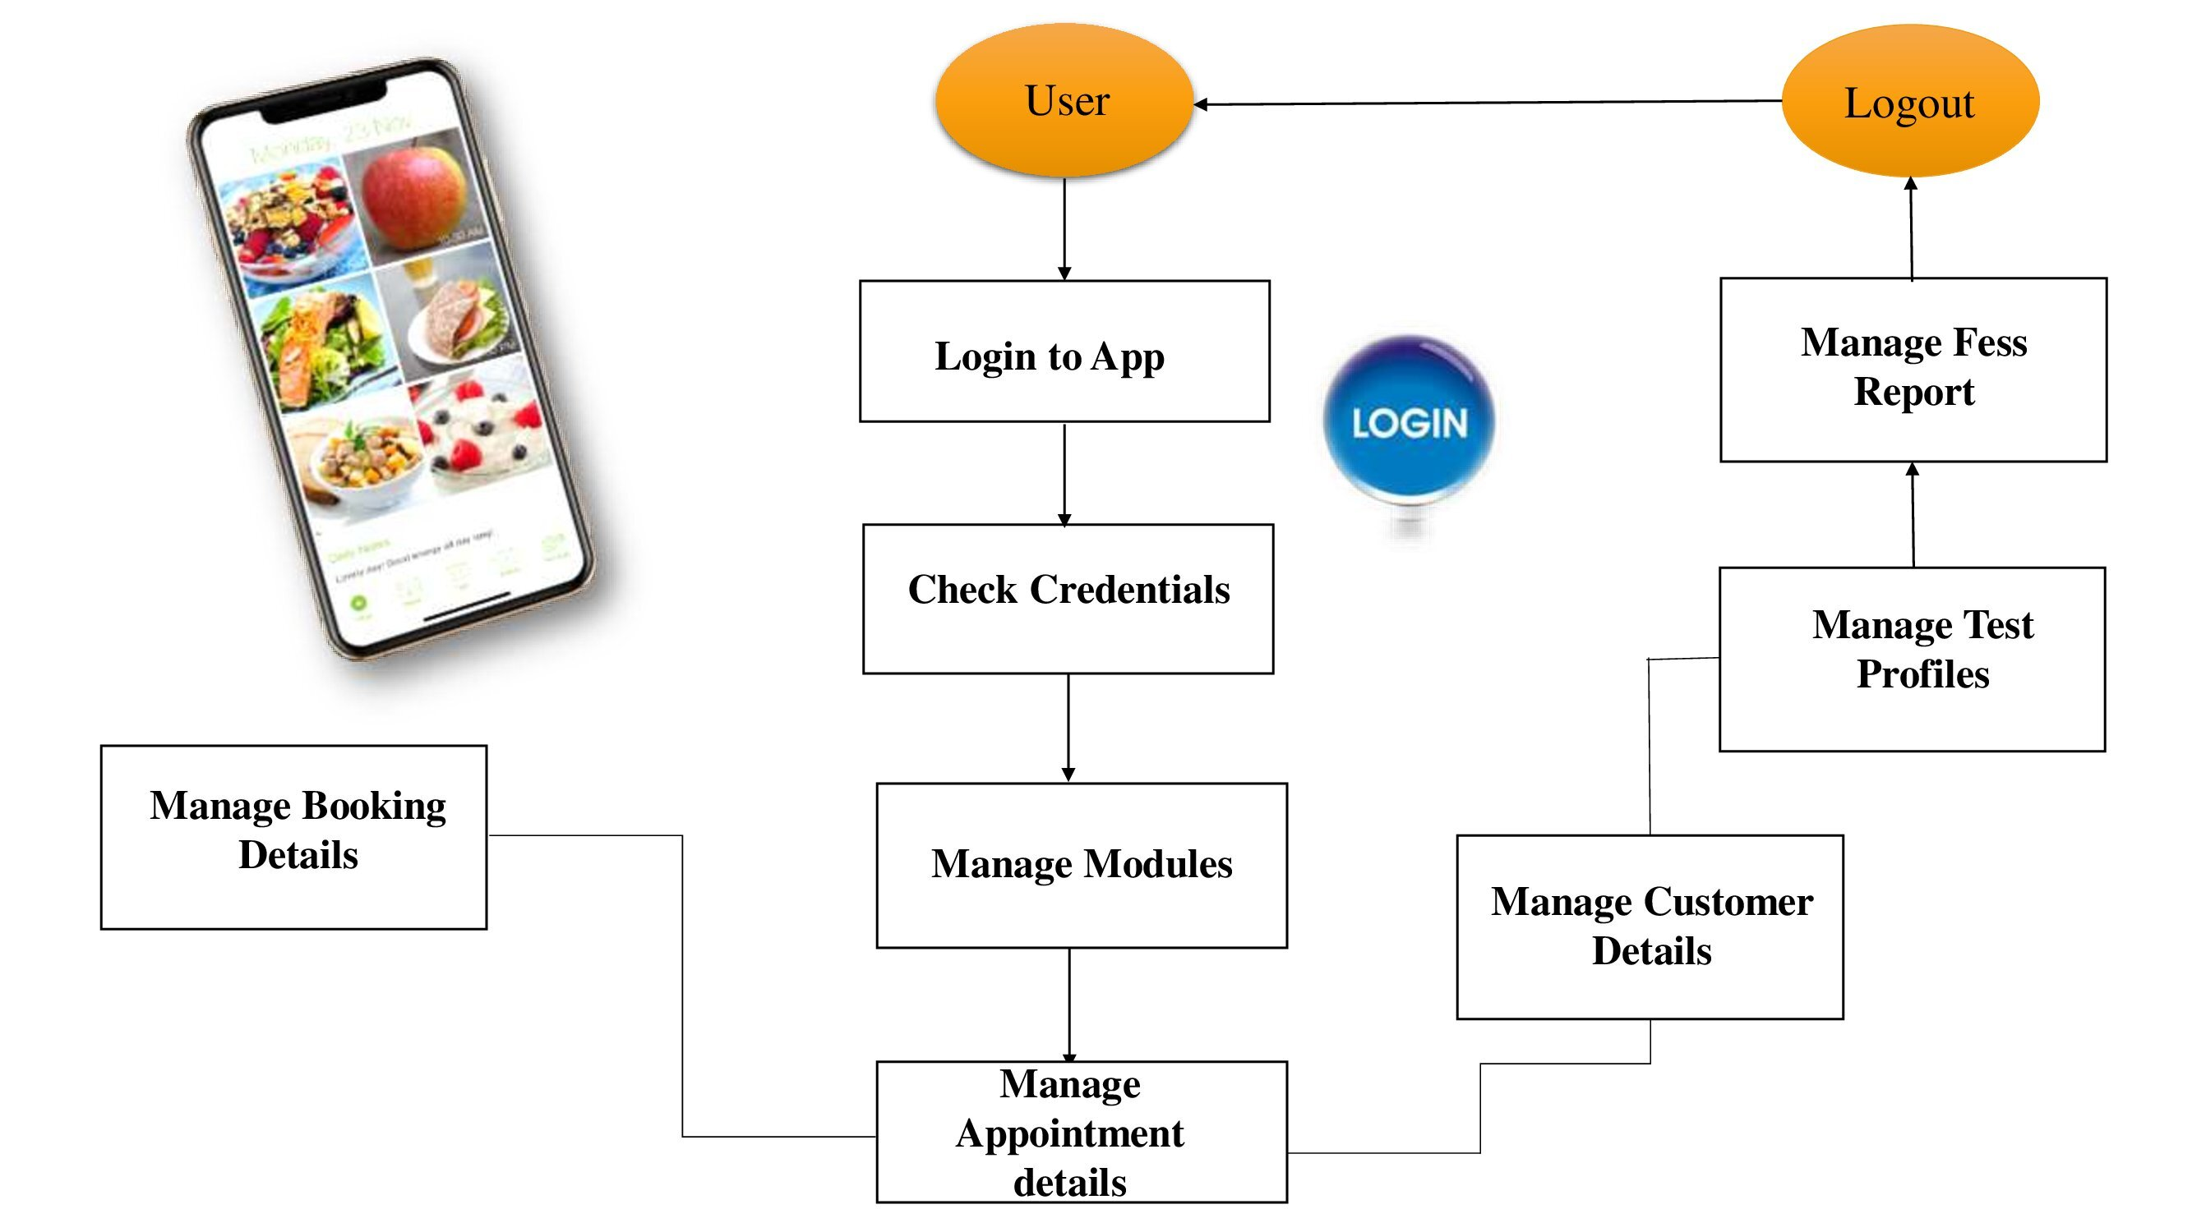

**User Stories**

Use the below template to list all the user stories for the product.

| **User Type** | **Functional Requirement (Epic)** | **User Story Number** | **User Story / Task** | **Acceptance criteria** | **Priority** | **Release** |
| --- | --- | --- | --- | --- | --- | --- |
| Customer (Mobile user) | Registration | USN-1 | As a user, I can register for the application by entering my email, password, and confirming my password. | I can access my account / dashboard | High | Sprint-1 |
|  |  | USN-2 | As a user, I will receive confirmation email once I have registered for the application | I can receive confirmation email & click confirm | High | Sprint-1 |
|  |  | USN-3 | As a user, I can register for the application through Facebook | I can register & access the dashboard with Facebook Login | Low | Sprint-2 |
|  |  | USN-4 | As a user, I can register for the application through Gmail | I can get confirmation code | Medium | Sprint-1 |
|  | Login | USN-5 | As a user, I can log into the application by entering email & password | I can access all the events | High | Sprint-1 |
|  | Dashboard | USN-6 | Describe how a user should interact with the system | I can access particular events | High | Sprint-1 |
| Customer (Web user) | Home | USN-7 | A web user can log into the google account &  Mobile number with security code | I can access all the events | High | Sprint-2 |
| Customer Care Executive | **Educational Qualification** | USN-8 | act as a link-man between a company | customers and resolves any such queries generated by its customers or clients with efficiency | High | Sprint-1 |
| Administrator | Input & Output | UNS-9 | Administrator can get user requirements Input & Output | User Queries solved immediately | High | Sprint-1 |
|  |  |  |  |  |  |  |
|  |  |  |  |  |  |  |